Here is an equilateral triangle with sides of length 1.

Let's define a unit of area, T, such that the triangle has area 1T.
Here are some parallelograms whose side lengths are whole numbers.
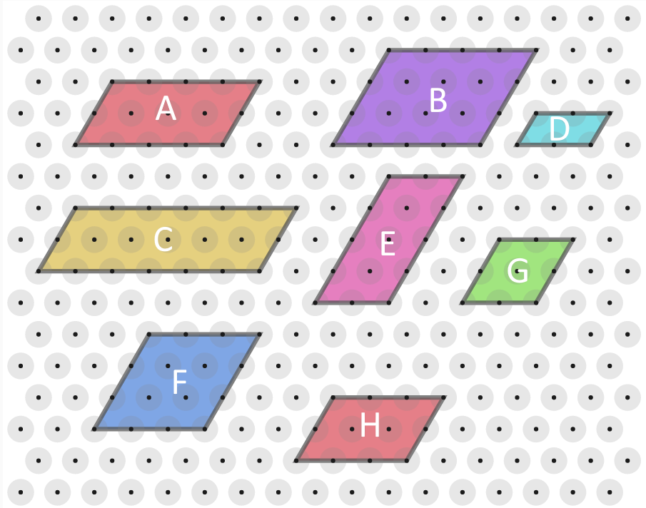
Can you find the area, in terms of T, of each parallelogram?
Compare the results with the lengths of their edges.
What do you notice?
Can you explain what you've noticed?
Can you find a similar result for trapeziums in which all four lengths are whole numbers?

